HANDS-ON: 3
BRANCHING AND MERGING

Branching:
- Create a new branch “GitNewBranch”.
- List all the local and remote branches available in the current trunk. Observe the “*” mark which denote the current pointing branch.
- Switch to the newly created branch. Add some files to it with some contents.
- Commit the changes to the branch.
- Check the status with “git status” command.

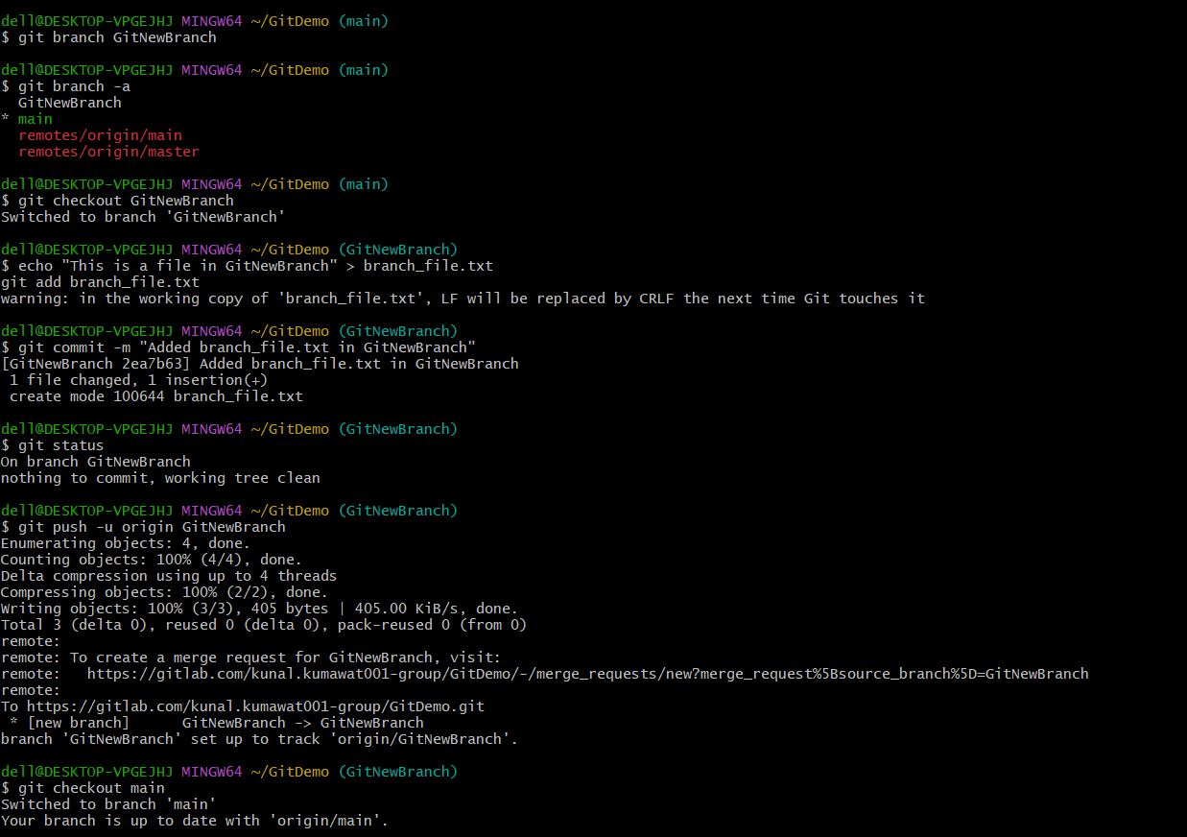

Merging:
- Switch to the master
- List out all the differences between trunk and branch. These provide the differences in command line interface.
- List out all the visual differences between master and branch using P4Merge tool.
- Merge the source branch to the trunk.
- Observe the logging after merging using “git log –oneline –graph –decorate”
- Delete the branch after merging with the trunk and observe the git status.

OUTPUT
